# Lab: Classes and Objects

Problems for in-class lab for the [Python Fundamentals Course @SoftUni](https://softuni.bg/trainings/3204/python-fundamentals-january-2021). Submit your solutions in the SoftUni judge system at <https://judge.softuni.bg/Contests/Practice/Index/1733>

## Comment

Create a class with name **"Comment"**. The **__init__** method should accept **3 parameters**

* **username**
* **content**
* **likes** (optional, 0 by default)

Use the **exact names** for your variables

***Note: there is no input/output for this problem. Test the class yourself and submit only the class***

### Example

|  |  |
| --- | --- |
| **Test Code** | **Output** |
| comment = Comment("user1", "I like this book")  print(comment.username)  print(comment.content)  print(comment.likes) | user1  I like this book  0 |

### Hint

Create a class named **"Comment"**. Create the **__init__** method and pass it the **three parameters**

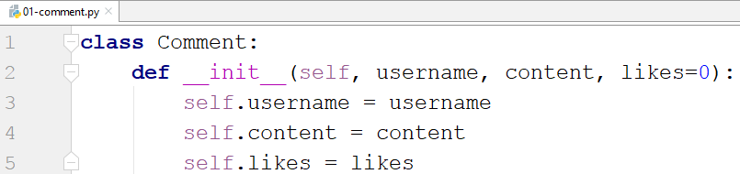

* we set the initial value of the likes to be 0

Test the class with the provided test code

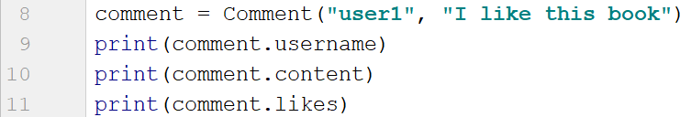

## Party

Create a class **Party** that only has an attribute called **people**. The **__init__** method should **not accept** any **parameters**. You will be given **names** of people (on separate lines) until you receive the command **"End"**. Use the created class to solve this problem. After you receive the end command print **2 lines**:

* **"Going: {people}" -** the people should be separated by comma and space **", "**
* **"Total: {total_people_going}"**

***Note: submit all of your code including the class***

### Example

|  |  |
| --- | --- |
| **Input** | **Output** |
| Peter  John  Katy  End | Going: Peter, John, Katy  Total: 3 |

### Hint

Start by creating the **class Party**

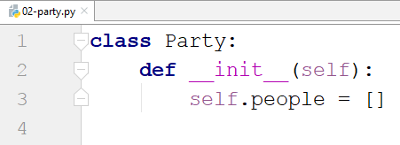

Create a new **instance** of the class



Read input and add it to the party people until you receive "End"

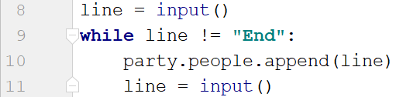

Finally, print the result



## Email

Create **class Email**. The **__init__** method should receive **sender**, **receiver** and a **content**. It should also have a default set to **False attribute** called **is_sent**. The class should have **two additional methods**:

* **send()** - sets the **is_sent** attribute to **True**
* **get_info()** - returns the following string: **"{sender} says to {receiver}: {content}. Sent: {is_sent}"**

You will receive some emails until you receive **"Stop"** (separated by single space). The first will be the **sender**, the second one – the **receiver** and the third one – the **content**

On the final line you will be given the **indices** of the **sent emails** separated by **comma and space**. Call the **send()** method for the given emails. For each email call the **get_info()** method

***Note: submit all of your code including the class***

### Example

|  |  |
| --- | --- |
| **Input** | **Output** |
| Peter John Hi,John  John Peter Hi,Peter!  Katy Lilly Hello,Lilly  Stop  0, 2 | Peter says to John: Hi,John. Sent: True  John says to Peter: Hi,Peter!. Sent: False  Katy says to Lilly: Hello,Lilly. Sent: True |

### Hint

First, we create the Email class with the **__init__** method and the **2 other methods**

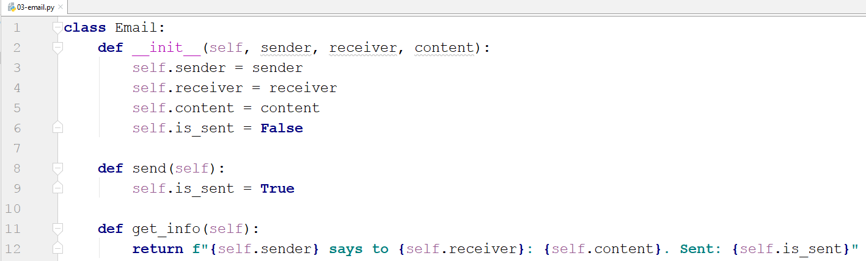

* The **is_sent** attribute is not passed to the function, it is set **automatically** to **False**
* The **send()** method does not accept parameters, since it always sets the **is_sent** attribute to **True**
* The **get_info()** method also does not accept parameters, it just returns a **string representation** of the object

We read the input until we receive **"Stop"**, we create an **Email** and add it to the emails list

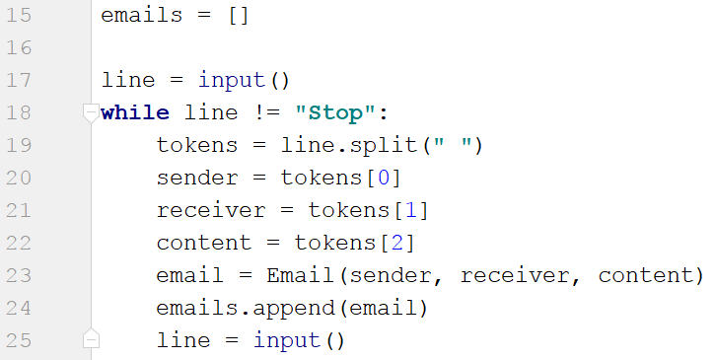

We read the indices of the sent emails, loop through them and call the **send()** method for each of the emails at those indices

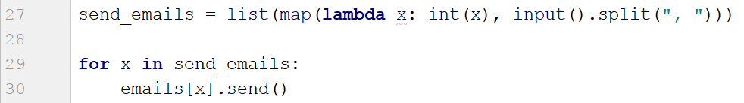

Finally, we print each of the emails

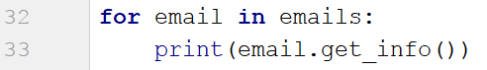

## Zoo

Create a **class Zoo**. It should have a **class attribute** called **__animals** that stores the **total count of the animals** in the zoo. The **__init__** method should only receive the **name** of the zoo. There you should also create **3 empty lists** (**mammals, fishes, birds**). The class should also have **2 more methods**:

* **add_animal(species, name)** - based on the species adds the name to the corresponding list
* **get_info(species)** - based on the species returns a string in the following format: **"{Species} in {zoo_name}: {names}"** and on another line **"Total animals: {total_animals}"**

On the **first line** you will receive the **name** of the zoo. On the **second line** you will receive number **n**. On the next **n lines** you will receive animal info in the format: **"{species} {name}**". **Add** the animal to the **zoo** to the **corresponding list**. The **"species"** command will be **mammal**, **fish** or **bird**. On the **final line** you will receive a **spеcies**. At the end, print all the info for that species and the total count of animals.

### Example

|  |  |
| --- | --- |
| **Input** | **Output** |
| Great Zoo  5  mammal lion  mammal bear  fish salmon  bird owl  mammal tiger  mammal | Mammals in Great Zoo: lion, bear, tiger  Total animals: 5 |

### Hint

Start by creating the class and the __init__ method

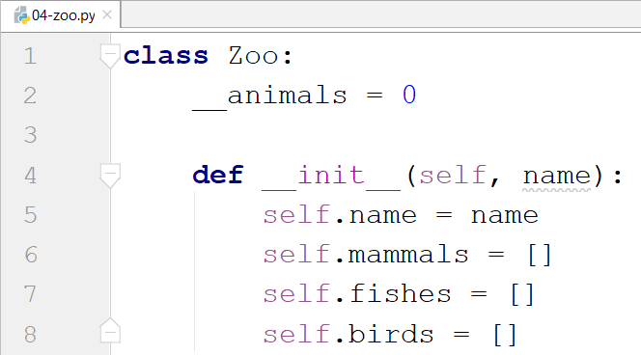

* the underscores in front of the animals attribute is used to express that it is private and is not meant to be used outside the class

Then create the other 2 methods for adding and getting the info

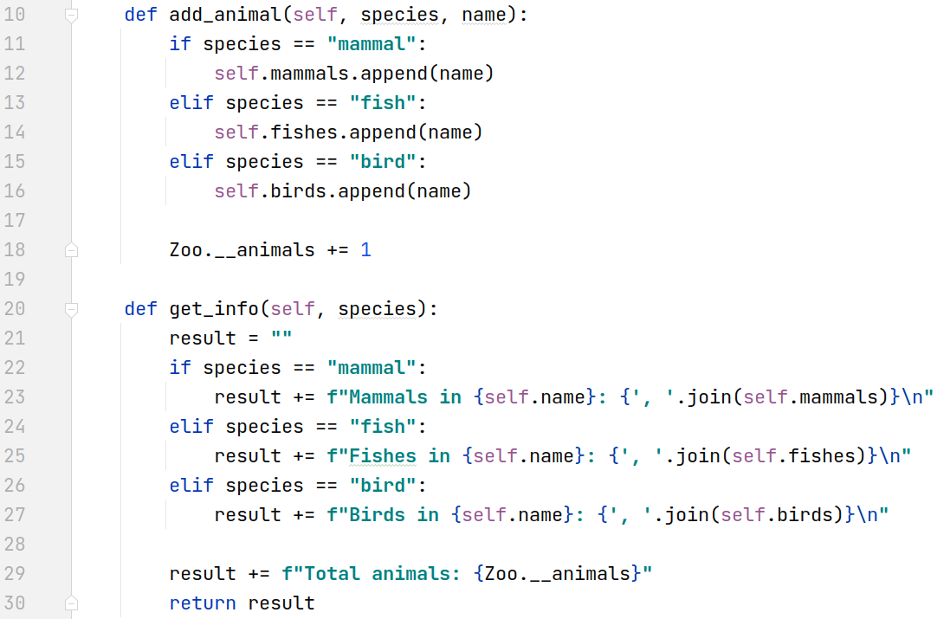

* We make the checks for the species inside the methods

Finally, implement the logic for reading the input and printing the result

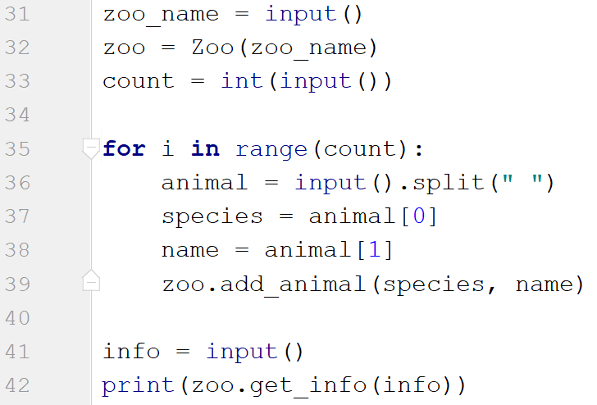

## Circle

Create a **class Circle**. In the **__init__** method the circle should only receive **one parameter** (its **diameter**). Create a class attribute called **__pi** that is equal to **3.14**. The class should also have the following methods:

* **calculate_circumference()** - returns the circumference of the circle
* **calculate_area()** - returns the area of the circle
* **calculate_area_of_sector(angle)** - given the central angle in degrees, returns the area that fills the sector

***Notes: Search the formulas in the internet. Name your methods and variables exactly as in the description! Submit only the class. Test your class before submitting!***

### Example

|  |  |
| --- | --- |
| **Test Code** | **Output** |
| circle = Circle(10)  angle = 5  print(f"{circle.calculate_circumference():.2f}")  print(f"{circle.calculate_area():.2f}")  print(f"{circle.calculate_area_of_sector(angle):.2f}") | 31.40  78.50  1.09 |

### Hint

First, let us create the **Circle** class, setting the attribute **__pi** and creating the **__init__** method

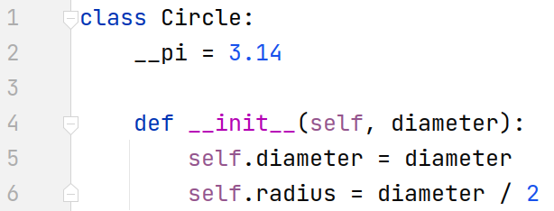

* We will be given the **diameter**, so the **radius** will be the **diameter** **divided** by **2**

Now, let us create the first method that calculates the **circumference**



After that, we create the method that calculates and returns the **area** of the circle



Finally, the method that calculates the **area of a particular sector**



Write some code to **test** your class before you submit it